

Development Request
Aria Systems

Order Status Report

CP# 102538

Program Add-in Template Description

Program Add-in Template

Program Add-in Header
Product: | Aria 27
Module: | EB
Customer name: | GMA
Installed Modules: | Al2, AP2, AR2, GL2, IC2, MA2, MF2, PO2,RM2,SO2, SO2, SR2, UP2,SY2, SM2, SP2, EB2,.
Parameters setting:

System Setting Report:
See attached GMAsetup.txt

Details Section
Add-in Name : Order Status Report
Add-in Objective : Create a new report for Order Status Report transaction.

Existing Initial situation: No report for printing what we have in the screen.

Description ( Processing ) :
We will create a report with a layout as follows.
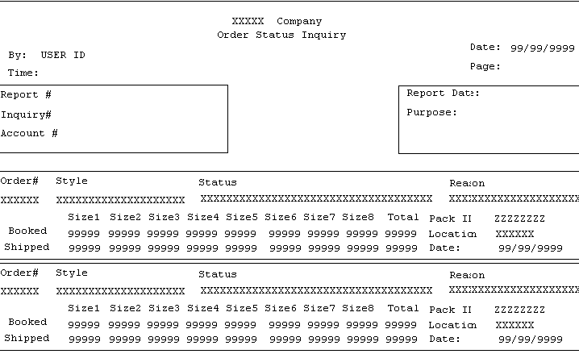
- Make sure that the Store# shows in the report.
- We need a 3rd detail line labeled “Difference” which is the difference between Shipped and Booked.
The option grid of the report will be:
- Report ID ……. BETWEEN
- Account ……….BETWEEN
- Order # ……….. List
- Sort by: Store/Style/Line Number
- Consolidate Stores: Yes/No
- Styles: All/Only Adjusted

Description:
When the user selects “Only Adjusted” styles display those styles only, i.e. styles that were adjusted by the 870.

Note:
If this Add-in contains the development of a new branching screen, please use the “New Program Template” to hold this requirement.

Development Cost | $900.00
Customer signature | Date signed
Payment Terms | 50 % due upon signing.  50% due upon delivery of the project.  (No work on this project will begin until the deposit is received)
Estimated completion time | 6 –8 weeks from the date of signing this document

